Personal Learning and Work Log
Name: Swapnil Milon Mondal (苏明)
Student ID: 1820262094
Team: PentaByte
Role: Content Lead & Video Tutorials PIC
Project: Algorithms, Data Structures, and Connectionist AI

Date: 26 October 2026

Stage 2 Requirements and Unit II Responsibility Clarification

Activity and Purpose
Today, I reviewed the Stage 2 assignment requirements and discussed the development of our team's 18-chapter content outline. My goal was to understand the expected deliverables, clarify my individual responsibilities, and identify how the learning materials should be developed and coordinated.
My Contribution
I reviewed the requirements for expanding the existing 18-chapter outline into detailed, beginner-friendly educational content. I also examined the differences between Markdown Content V2.0 and the Study Guide and Test Bank. Furthermore, I discussed how the team could distribute chapter-development tasks to avoid overlapping responsibilities. I clarified my responsibilities for my assigned Unit II, which include preparing the PowerPoint presentation, developing the Study Guide, and producing a video tutorial based on the presentation.
Outcome
I gained a clearer understanding of the Stage 2 deliverables and how Markdown content, PowerPoint presentations, study guides, and video tutorials support one another. I also established a clearer understanding of my responsibilities and the importance of coordinating content development with other team members.

Learning and Reflection
Initially, I was uncertain about the extent of my individual responsibilities, particularly whether I needed to prepare materials for all 18 chapters or focus on my assigned unit. After reviewing the assignment requirements and discussing the responsibilities with ChatGPT, I better understood the relationship between the different deliverables and the importance of dividing the work according to individual assignments. I also learned that the PowerPoint, Study Guide, and video tutorial should follow consistent content and explanations to provide students with a connected learning experience.
Purpose: To understand the Stage 2 requirements, clarify my responsibilities for Unit II, and establish an appropriate approach to preparing the learning materials.
Verification: The clarification was compared with the previously shared Stage 2 assignment instructions and the team's project outline. Individual responsibilities were further clarified through subsequent team planning.
Evidence: Screenshots of the ChatGPT discussion regarding Stage 2 requirements and responsibilities, the previously prepared 18-chapter project outline, and the Stage 2 assignment instructions.

The time of research, about the topics and all about the project’s 2nd stage__
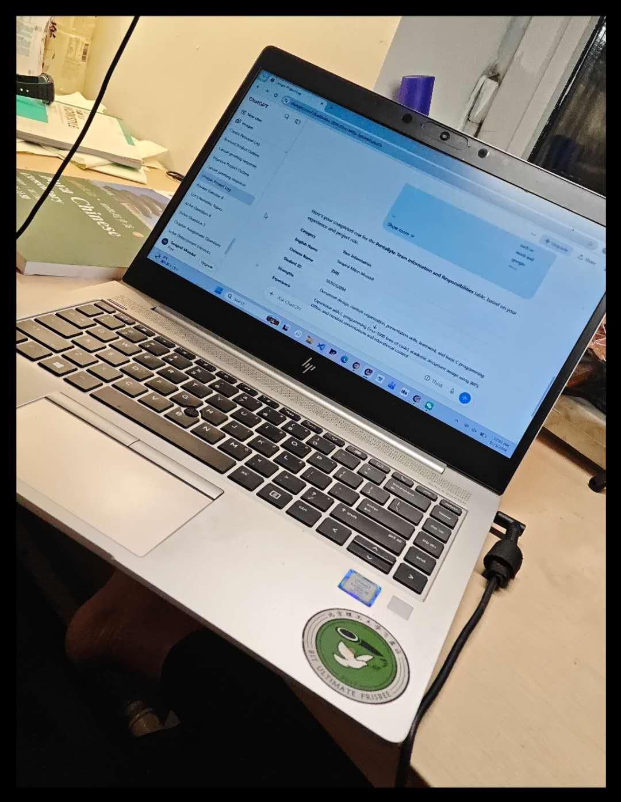
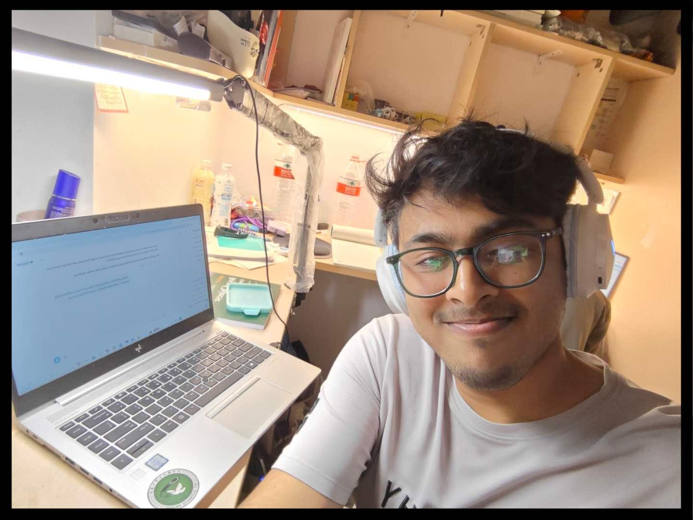

Using ChatGpt for better understand about the project___
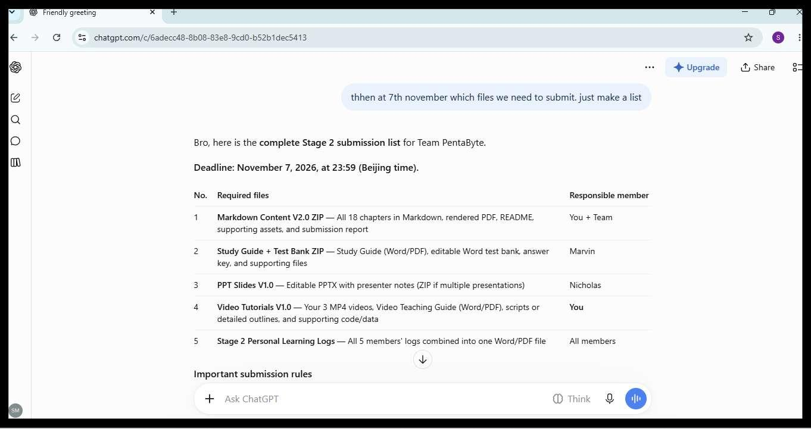

Date: 28 October 2026

Content Development and Review of Project Learning Materials

Activity and Purpose
Today, I continued working on the PentaByte educational materials, focusing on improving the organization, completeness, and consistency of the learning content. My main objective was to review the progress of the existing materials, identify missing components, and ensure that the content followed the agreed 18-chapter structure.

My Contribution
As the Content Lead, I continued developing and organizing the project's learning materials according to the established five-unit and 18-chapter structure. I reviewed the content across different units to identify inconsistencies and areas requiring further development.
During the review, I identified that supporting code files had been prepared only for the final unit, while the other relevant units also required corresponding programming examples and code files. I highlighted this gap and emphasized the importance of providing practical coding materials alongside theoretical explanations throughout the learning resources.
Outcome
The review helped identify an important gap in the project's educational materials, particularly the incomplete distribution of supporting code files across the units. It also established several priorities for further development, including completing Master Markdown V2.0, organizing the required code files, and conducting a systematic quality review before submission.
Learning and Reflection
Through this work, I developed a better understanding of the importance of maintaining consistency and completeness when preparing educational materials across multiple units. I also recognized that theoretical explanations alone are insufficient for an effective programming learning resource. Practical examples, runnable code, and clearly organized supporting materials are equally important in helping beginners understand and apply technical concepts.
Purpose: To improve the completeness and consistency of the PentaByte learning materials, identify missing supporting resources, and prepare the content for further development and quality review.
Verification: The identified gaps were based on reviewing the available project learning materials and supporting code files. Further verification is required by checking the completed code files against the relevant units and chapters in Master Markdown V2.0.
Evidence: The agreed 18-chapter project outline, available unit learning materials, existing supporting code files, and relevant project review records.

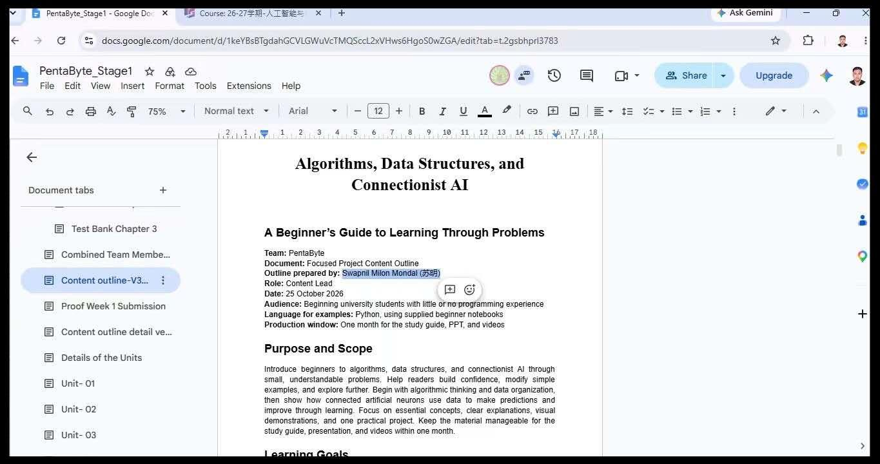

Date: October 30, 2026

Completion of Detailed Content Outline and Unit Allocation Meeting

Activity and Purpose
Today, I completed the detailed version of the PentaByte Content Outline V3.0, further developing the project's academic structure and organizing the learning topics. Later in the evening, our team held a meeting to discuss the distribution of individual responsibilities and allocate chapters among team members through a lottery. The purpose was to establish a fair division of work and clarify each member's responsibilities for the next stage of the project.
My Contribution
I completed the detailed version of the V3.0 content outline, contributing to the development and organization of the project's overall learning structure. During the evening meeting, I participated in the discussion and the lottery-based allocation of units. Through this process, I was assigned Unit II, which became my individual area of responsibility.

My assigned tasks include:
- Preparing a PowerPoint presentation covering the chapters in Unit II.
- Developing a detailed Study Guide for the assigned chapters.
- Producing a video tutorial based on the Unit II PowerPoint presentation.
Outcome
The detailed version of the PentaByte Content Outline V3.0 was completed, providing a more developed structure for the learning materials. The team also established an initial division of responsibilities through the lottery. As a result, I received Unit II and gained a clearer understanding of the three major deliverables I needed to prepare for my assigned unit.
Learning and Reflection
Today's activities helped me understand the importance of teamwork and collaborative decision-making in a group project. I realized that group meetings can be both productive and enjoyable because they provide opportunities to exchange ideas, learn new things from other members, and understand different perspectives. I particularly enjoyed the lottery-based unit allocation because it made the division of responsibilities an engaging experience while ensuring that everyone received an assigned area of work. This experience also increased my motivation to take responsibility for Unit II and develop its learning materials effectively.
Purpose: To complete the detailed PentaByte Content Outline V3.0, participate in the team's responsibility-allocation meeting, and establish my individual deliverables for Unit II.
Verification: The completed detailed content outline can be checked against the team's agreed project structure. My Unit II allocation and the associated deliverables were established through the team's evening meeting and lottery process.
Evidence: The completed detailed PentaByte Content Outline V3.0, relevant team meeting records, and available evidence of the lottery-based unit allocation.

The group meeting and the funny way of Unit/Chapter selection__
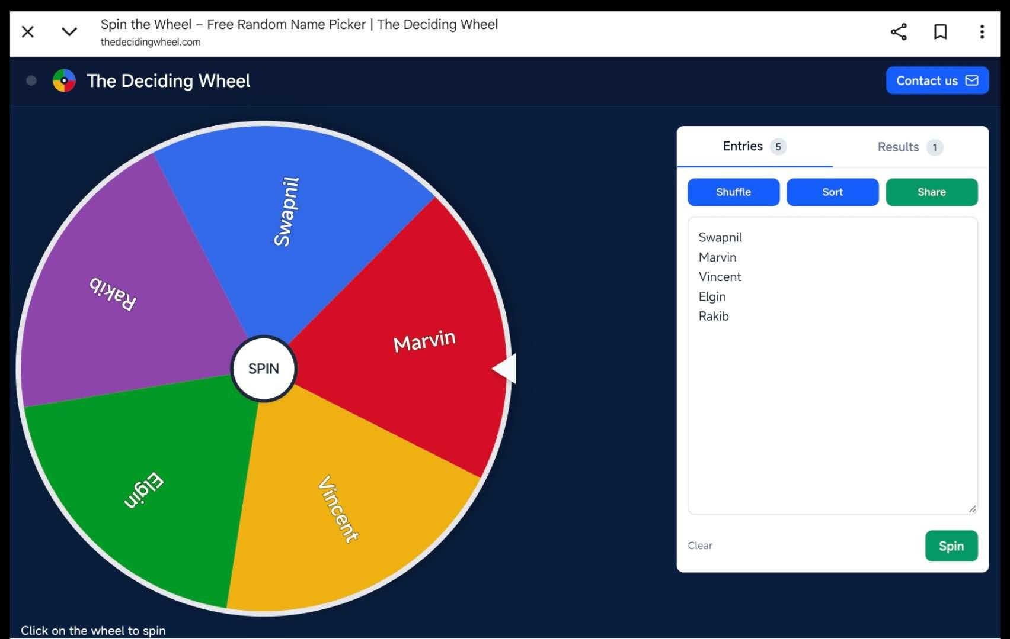
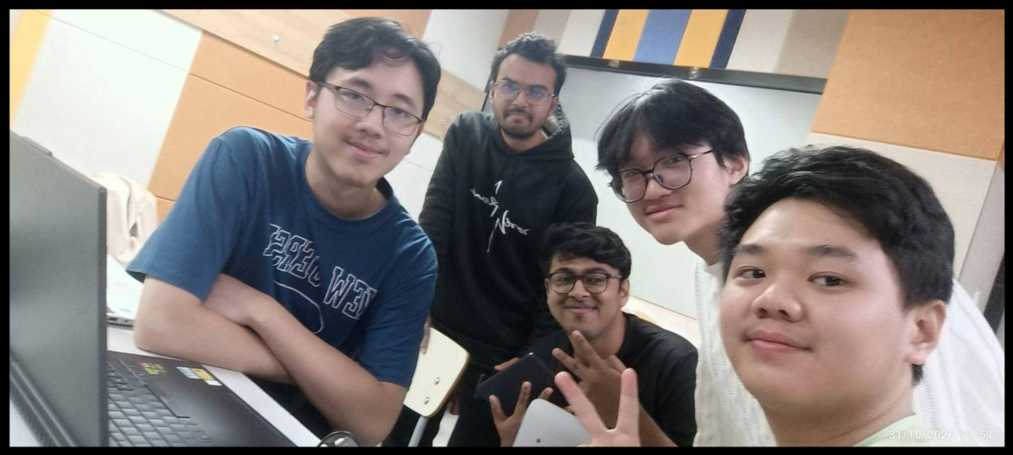

Date: November 1, 2026

Unit II Content Study, Python Practice, and Learning Material Preparation

Activity and Purpose
Today, I focused on studying all the chapters in Unit II to develop a thorough understanding of the concepts before beginning the production of the learning materials. I spent considerable time reviewing the topics, understanding their explanations, and exploring how the concepts could be demonstrated through practical Python programming. I also reviewed previous-year team projects to gain a better understanding of the expected quality, structure, and presentation of the final deliverables.
My Contribution
I studied the chapters in Unit II in detail, focusing on understanding the underlying concepts rather than simply reading the explanations. To strengthen my practical understanding, I used Visual Studio Code to run Python programs and experiment with basic code examples related to the topics.
In addition, I began developing ideas and planning the structure of the Unit II PowerPoint presentation. I also considered different approaches to preparing the Study Guide, with particular attention to making the explanations understandable and accessible to beginner-level students. Furthermore, I reviewed previous-year projects to identify useful approaches, presentation styles, and ideas that could help improve the quality of my own work.
Outcome
I developed a stronger understanding of the Unit II topics and gained more confidence in using Python through practical exercises in Visual Studio Code. I also generated initial ideas for the PowerPoint presentation and established a preliminary direction for developing a beginner-friendly Study Guide. Reviewing previous-year projects provided additional insights into the expected standards and helped me identify ways to improve my deliverables.
Learning and Reflection
Today's work helped me realize that preparing effective educational materials requires a deeper understanding of the subject than simply reproducing information from existing content. Practicing Python independently allowed me to become more comfortable with writing and running basic programs, while connecting theoretical concepts with practical applications. I also learned the importance of studying previous-year projects as references for understanding quality expectations and improving my own work. Most importantly, I recognized that learning the material thoroughly before designing the teaching resources would help me explain the concepts more confidently and effectively to beginners.
Purpose: To strengthen my understanding of all Unit II chapters, improve my practical Python programming skills, and prepare initial ideas for the PowerPoint presentation and beginner-friendly Study Guide.
Verification: Python practice can be verified through the relevant code files and program outputs. The reviewed Unit II materials and previous-year project references can also be used to verify the preparation and research activities.
Evidence: Relevant Python code files and execution screenshots from Visual Studio Code, and Google Colab Unit II learning materials, notes and initial PowerPoint and Study Guide planning, and reviewed previous-year project examples.

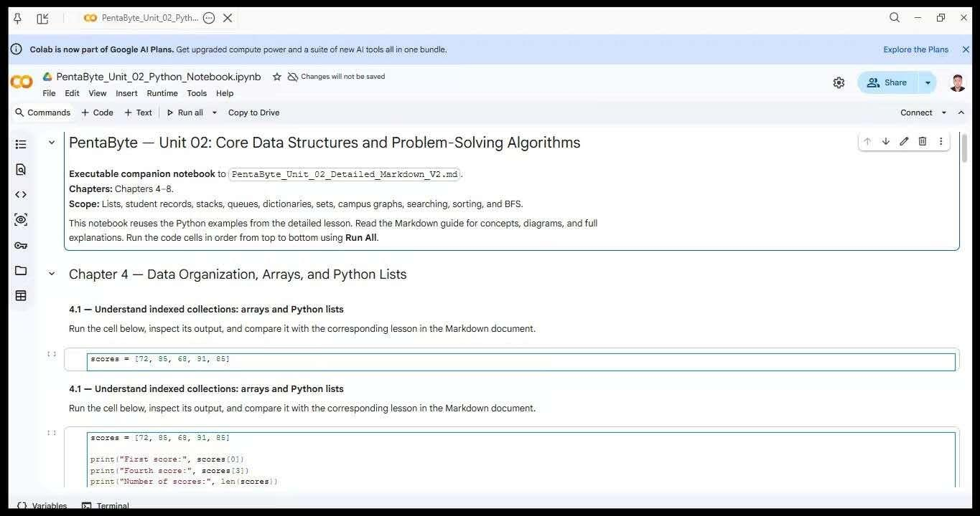
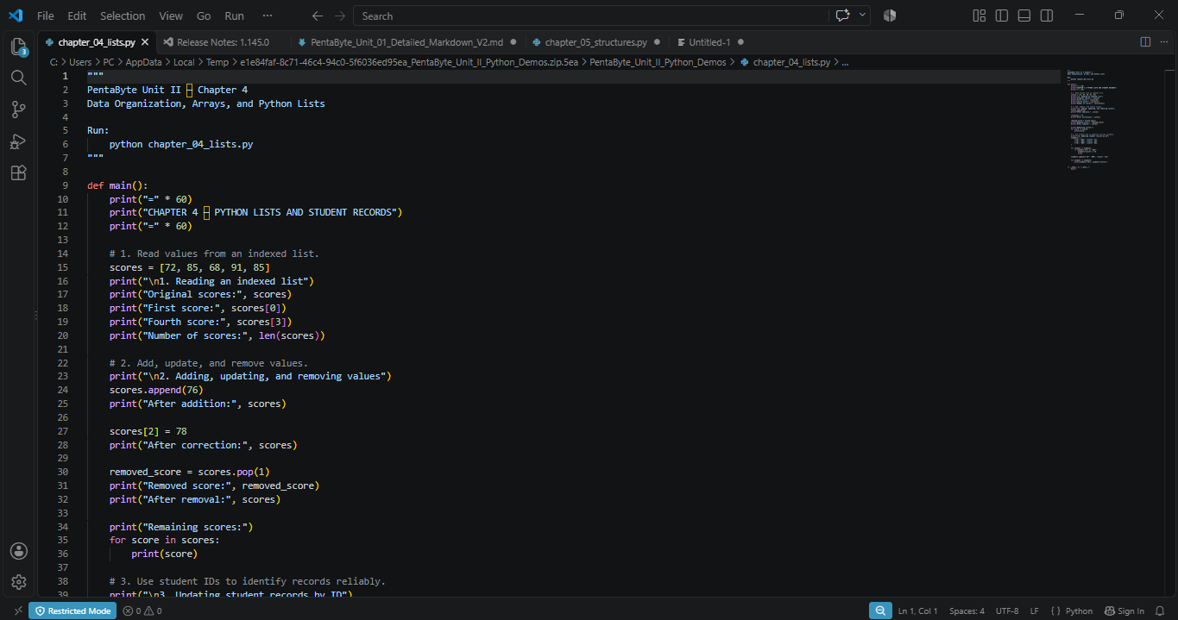
Visual Code Running for Chapter 4__ Google Colab Running for Chapter 4__

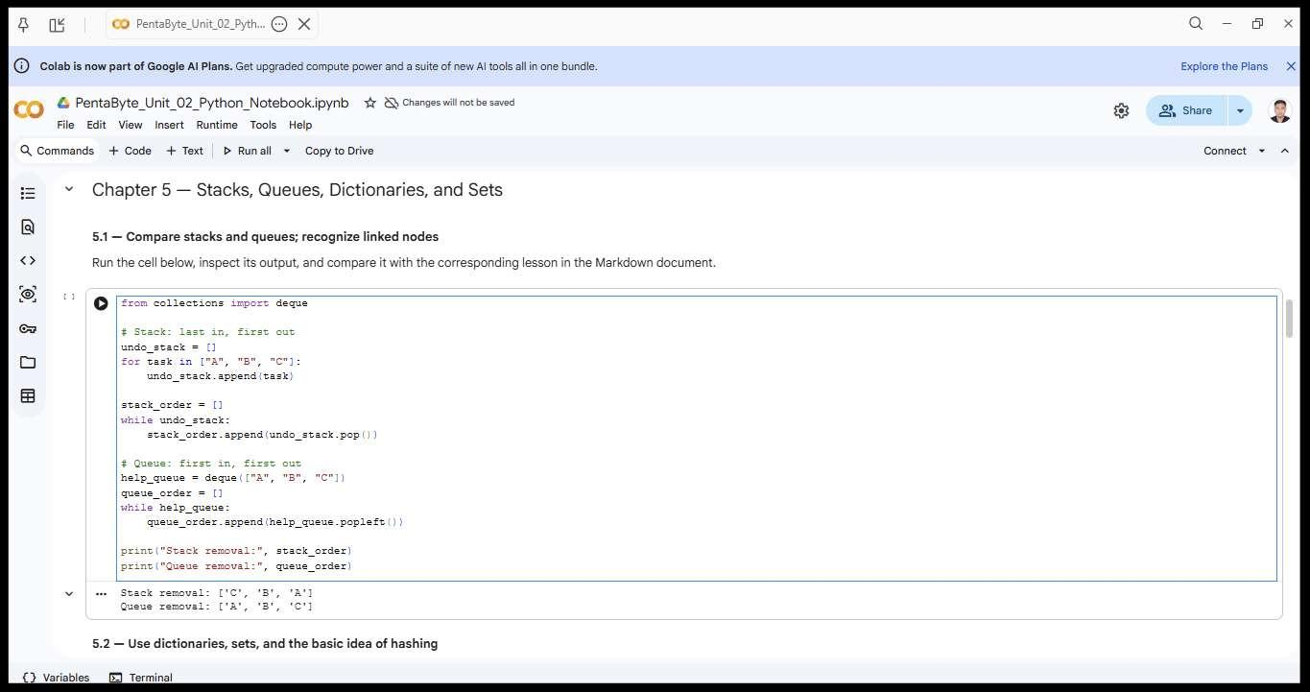
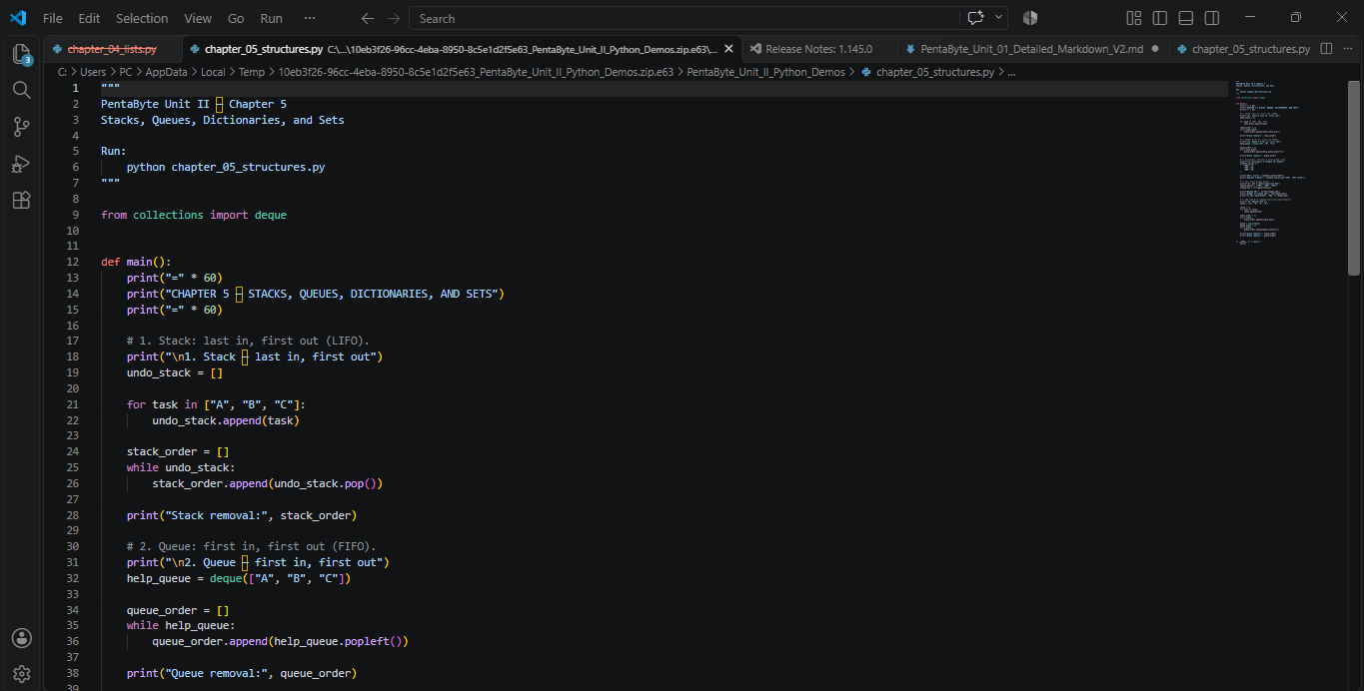
Visual Code Running for Chapter 5__ Google Colab Running for Chapter 5__

Date: November 1, 2026

Python Demonstrations and Development of Unit II Learning Materials
Activity and Purpose
Today, I continued working on the practical development of my assigned Unit II learning materials, focusing on Chapters 6 and 7. My main objective was to strengthen my understanding of the concepts and prepare relevant Python demonstrations that could be executed in Visual Studio Code (VS Code). I focused on connecting the theoretical explanations with practical examples that could help beginner-level students understand how these data structures and algorithms work.
My Contribution
I worked on the following two chapters:
- Chapter 6 — Trees, Heaps, and Graph Representations: Reviewed the basic concepts of trees and heaps and worked on representing the five-location campus map using a Python adjacency list. I also explored how to modify an undirected graph by adding a new connection while maintaining consistency between the connected locations.
- Chapter 7 — Searching and Elementary Sorting: Studied linear search and binary search, focusing on their working principles and differences. I also reviewed the insertion-sort process through step-by-step examples and prepared Python demonstrations for searching and sorting operations.
I organized the practical examples into Python files so that they could be opened and executed in Visual Studio Code. This would also provide useful programming demonstrations and visual evidence for the project documentation.
Outcome
I made further progress in developing the practical programming materials for Unit II. I strengthened my understanding of graph representation, adjacency lists, searching techniques, and elementary sorting. I also established a clearer connection between the theoretical explanations in the learning content and their corresponding Python demonstrations.

Learning and Reflection
Today's work helped me understand how different data structures can represent relationships and how algorithms can operate on organized information. I found the campus graph example particularly useful because it demonstrated how real-world connections can be represented through vertices, edges, and adjacency lists. I also learned more about the importance of sorted data when applying binary search and how insertion sort gradually organizes values into the correct order. Preparing practical demonstrations helped me approach the topics from both a learner's and a teacher's perspective.
Purpose: To develop a deeper understanding of Chapters 6 and 7, prepare practical Python demonstrations, and strengthen the connection between theoretical concepts and programming applications in Unit II.
Verification: The Python demonstrations can be verified by executing the corresponding Chapter 6 and Chapter 7 files in Visual Studio Code and comparing their outputs with the expected results in the Unit II learning content.
Evidence: Chapter 6 and Chapter 7 Python code files, relevant GOOGLE COLAB Code screenshots showing code execution and outputs, and the Unit II Detailed Learning Content V3.0.

Google Colab Running for Chapter 6__
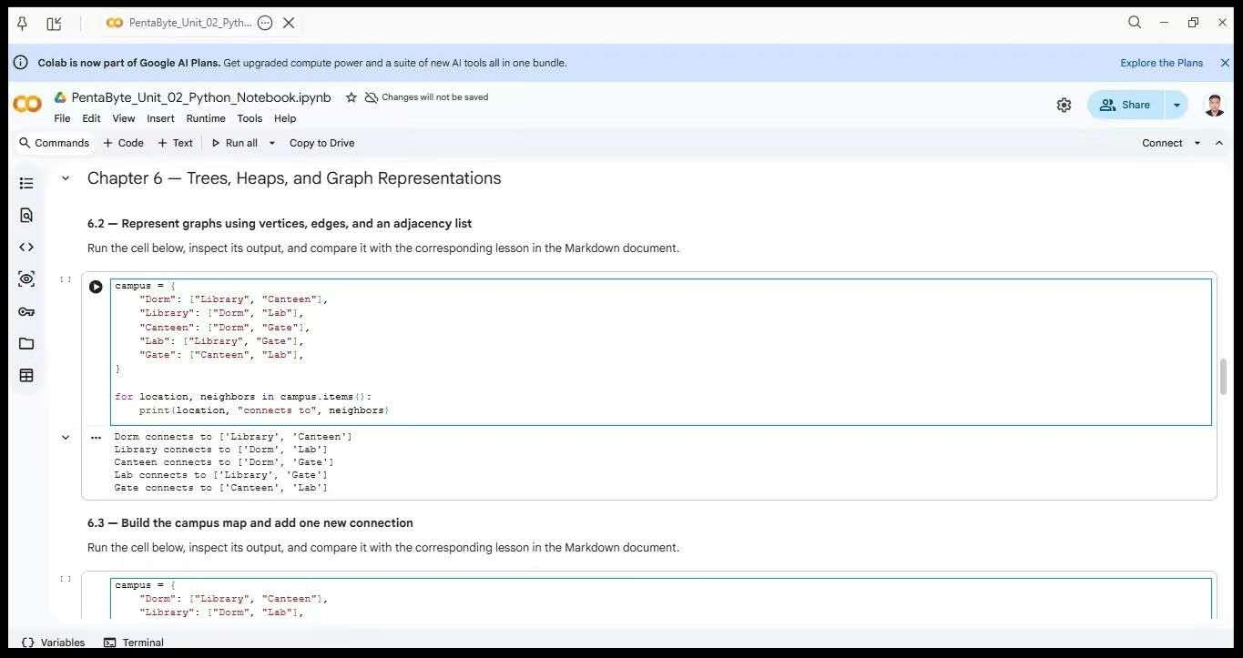

Google Colab Running for Chapter 7__
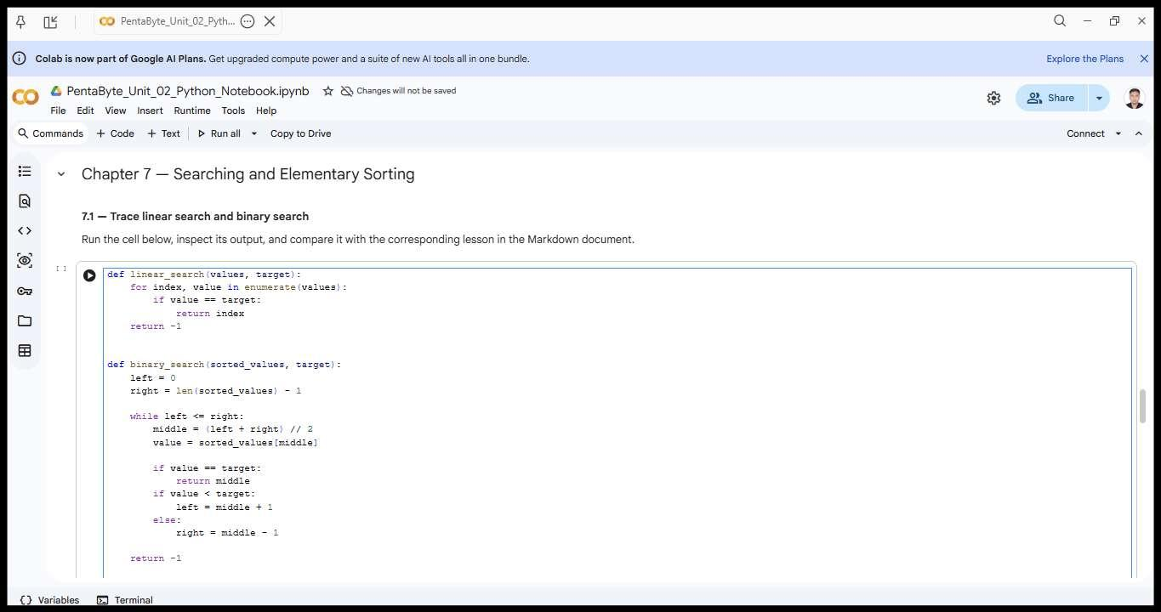

Date: November 3, 2026

Chapter 8 Development and Team Meeting
Activity and Purpose
Today, I focused on completing my work on Chapter 8, the final chapter of my assigned Unit II. I concentrated on understanding graph traversal and shortest-path algorithms, particularly Breadth-First Search (BFS), and how these concepts could be explained through practical examples. In addition to my individual work, I participated in a team meeting to discuss our ongoing project activities and coordinate our work.
My Contribution
I worked on Chapter 8 — Graph Traversal and Shortest Paths, focusing on the following topics:
- Understanding Breadth-First Search (BFS) and how it explores connected vertices in a graph.
- Studying how queues and visited sets are used to manage graph traversal and prevent repeated visits.
- Understanding how parent records can be used to reconstruct a route between two locations.
- Exploring how BFS identifies a route with the fewest edges in an unweighted graph.
- Reviewing the campus map example and the situation in which a destination becomes unreachable.
I also worked on understanding the corresponding Python demonstration and how its execution could illustrate the BFS process and route-finding results.
Furthermore, I participated in a team meeting as part of our ongoing project collaboration and coordination.
Outcome
I completed my focused work on Chapter 8, covering the main concepts of graph traversal and BFS-based route finding. This brought my individual chapter study and practical preparation across Unit II to Chapter 8. The team meeting also provided an opportunity to participate in group communication and discuss the ongoing project work.
Learning and Reflection
Through today's work, I developed a better understanding of how graph traversal algorithms explore connections and identify routes. I found the use of queues and visited sets particularly important because they help explain how BFS systematically explores a graph without repeatedly processing the same locations. I also learned that finding the shortest path in an unweighted graph means minimizing the number of edges rather than necessarily minimizing physical distance or travel time.
Participating in the team meeting reminded me that individual work and group collaboration are both important for completing a successful project. Sharing progress and communicating with team members helps maintain coordination and gives everyone a better understanding of the overall project.
Purpose: To develop a clear understanding of Chapter 8, complete the learning and practical preparation for the final chapter of Unit II, and participate in team coordination through a project meeting.
Verification: The Chapter 8 content can be checked against the Unit II Detailed Learning Content V3.0. The BFS demonstration can be verified by executing the corresponding Python code and comparing its results with the expected outputs. The team meeting can be verified through available meeting records or screenshots.
Evidence: Chapter 8 learning materials, relevant Python code and Google colab execution screenshots, and available evidence of the team meeting.

Real-life working evidence as a running code__
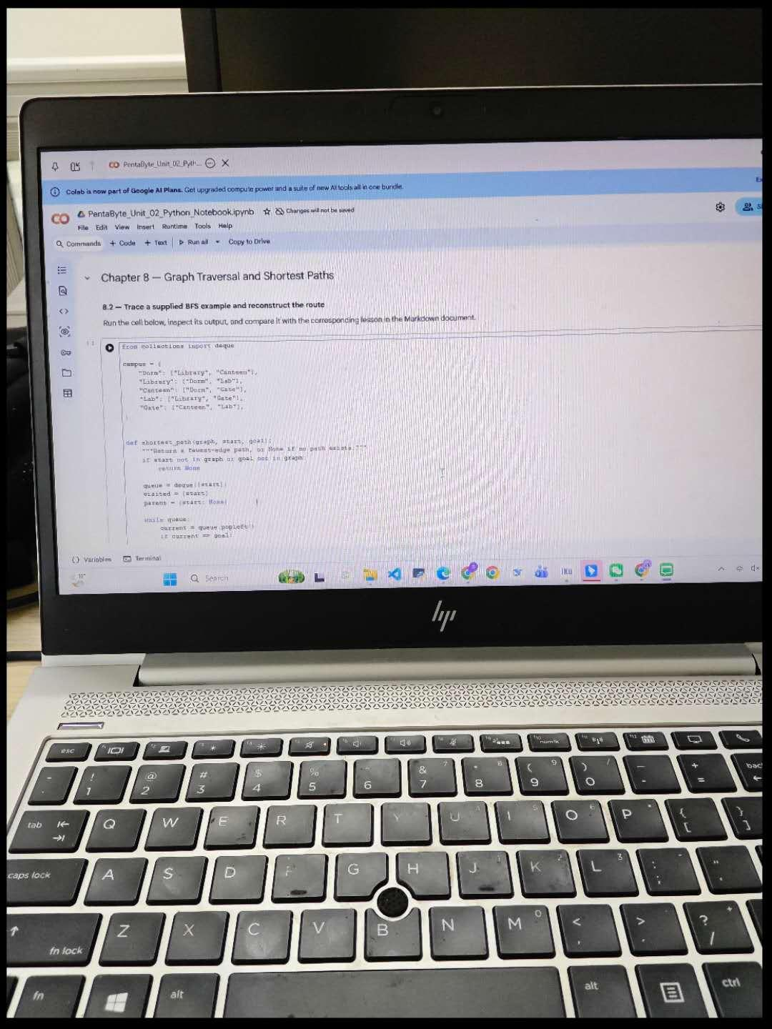
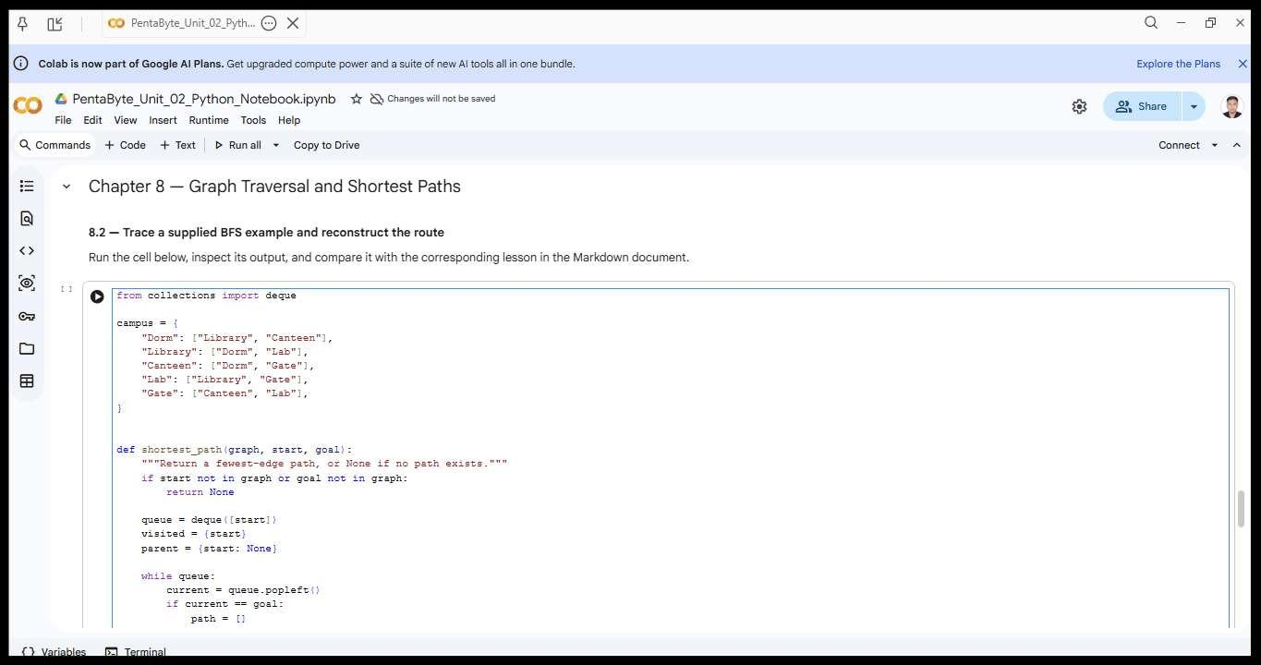
Google colab Running for Chapter 8___

Date: November 4, 2026

Completion of Unit II PowerPoint and Additional Python Practice

Activity and Purpose
Today, I focused primarily on completing the PowerPoint presentation for my assigned Unit II, covering Chapters 4–8. My main objective was to develop a professional, visually engaging, and educational presentation that could effectively communicate the chapter contents to beginner-level university students. Alongside the presentation development, I continued practising Python programming using concepts covered in Unit II and coordinated with team members regarding the presentation and Study Guide templates.
My Contribution
I completed the PowerPoint presentation covering all five chapters of Unit II, fulfilling one of my major Stage 2 responsibilities. Since I have experience and confidence in visual design, I found the slide-design process relatively comfortable. However, collecting suitable and relevant images from Google and other online resources required considerable time and effort. I carefully searched for visual materials that could support the explanations and make the presentation more engaging and understandable.
In addition to the PowerPoint development, I practised additional Python programming using topics covered in Unit II to strengthen my practical understanding of the subject.
I also communicated with the team leader to clarify whether all members were expected to follow a common PowerPoint template to maintain consistency across the team's presentations. Furthermore, I contacted Marvin to obtain information about the Study Guide template so that I could follow the team's established design and formatting requirements when preparing my Study Guide.
Outcome
I completed the Unit II PowerPoint presentation, covering Chapters 4–8, and made significant progress in fulfilling my assigned presentation responsibility. I also strengthened my practical programming knowledge through additional Python exercises. The coordination with the team leader and Marvin helped me address the requirements for maintaining consistency between the team's learning materials and understand the Study Guide template requirements.
Learning and Reflection
Today's work helped me improve my ability to combine visual design with educational content. Although designing the slides was relatively easy for me, I realized that finding appropriate images and visual resources requires patience, research, and careful selection. I also recognized that a professional presentation should not rely on attractive design alone; its visuals must support the learning objectives and help students understand the concepts.
Additionally, practising Python alongside presentation development helped me maintain a connection between theoretical knowledge and practical programming. I also learned that maintaining consistent templates across team deliverables is important for creating a unified and professional learning experience. Communication with the team leader and other members is therefore essential, especially when multiple people are developing different resources for the same project.
Purpose: To complete the Unit II PowerPoint presentation, strengthen practical Python programming skills through additional exercises, and coordinate with team members regarding common presentation and Study Guide templates.
Verification: The completed PowerPoint can be reviewed to verify the coverage and visual organization of Chapters 4–8. Python practice can be verified through the relevant code files and execution screenshots. Team template requirements can be cross-checked against the communication with the team leader and the Study Guide template information provided by Marvin.
Evidence: The completed Unit II PowerPoint presentation, relevant screenshots of Python code and execution in Visual Studio Code, selected image resources used in the presentation, and available communication records regarding the common presentation and Study Guide templates.
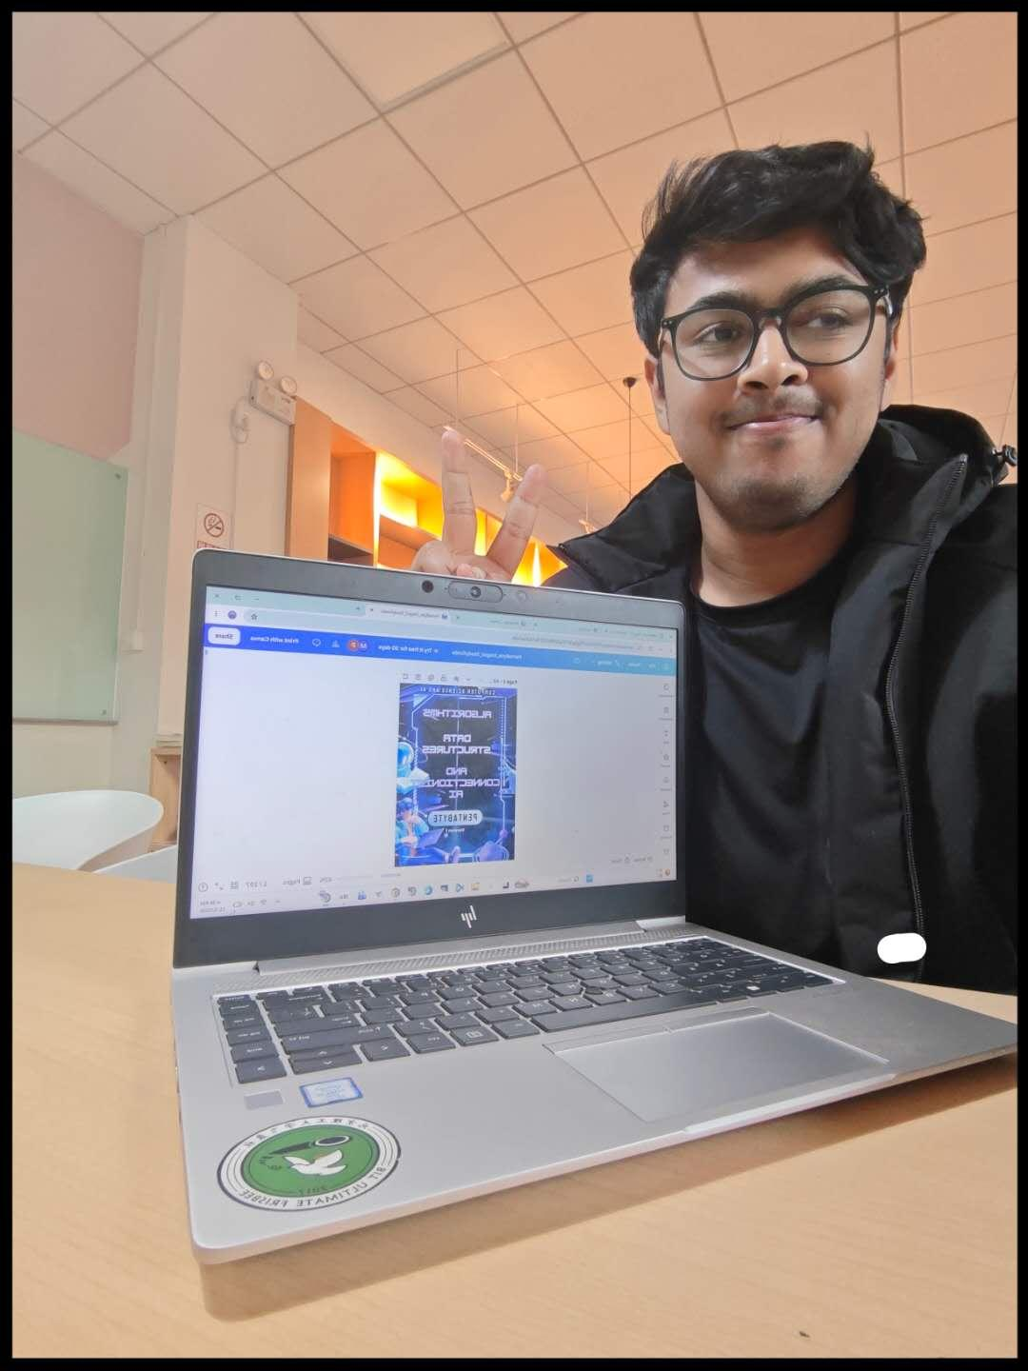
Making the PPTs for the Unit-2 after classes___

The first page of the slide__
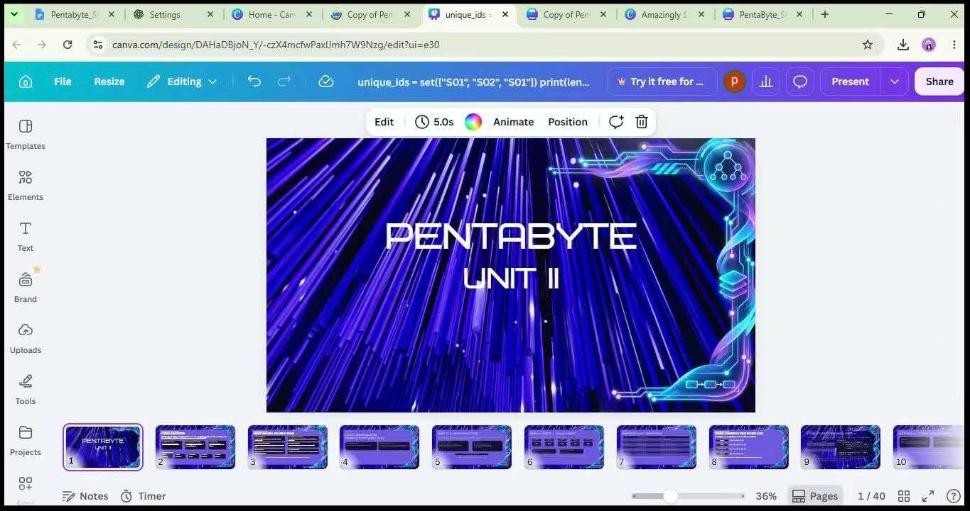

Date: November 5, 2026

Beginning Unit II Study Guide Development and Team Progress Meeting

Activity and Purpose
Today, I began developing the Study Guide for my assigned Unit II, covering Chapters 4–8. My primary objective was to start transforming the existing learning content into a structured and beginner-friendly Study Guide. In addition to my individual work, I participated in a team meeting to review the overall progress of our Stage 2 projects, exchange ideas, and discuss important topics related to our remaining responsibilities.
My Contribution
I started working on the development of the Unit II Study Guide, which is one of my major individual responsibilities for Stage 2. I also reviewed previous-year assignment examples to better understand the expected quality, structure, and presentation standards for the Study Guide.
Furthermore, I participated in a team progress meeting where members shared updates about their respective work, helped one another, and discussed several important project-related topics. I also updated my Personal Learning Log to maintain an organized record of my daily activities, contributions, and learning progress.
Outcome
The initial development of the Unit II Study Guide began, marking the next stage of my individual work after completing the PowerPoint presentation. Reviewing previous-year assignments provided additional references for understanding the expected standards. The team meeting also supported collaboration by allowing members to share progress, exchange ideas, and discuss important matters concerning the project's development.
Learning and Reflection
Today's activities helped me recognize the importance of collaboration and continuous progress monitoring in a group project. I found the team meeting valuable because members could support one another, share different perspectives, and discuss challenges together. Reviewing previous-year assignments also helped me better understand the expectations for producing high-quality educational materials. I realized that developing a Study Guide requires careful organization and consideration of the learning needs of beginners. Maintaining my Personal Learning Log also reminded me of the importance of documenting project activities consistently throughout the development process.
Purpose: To begin developing the Unit II Study Guide, review previous-year assignment examples for quality and formatting references, participate in team progress discussions, and maintain an updated record of personal project activities.
Verification: The initial Study Guide development can be verified through the available draft materials. The reviewed previous-year assignments can be used as references for evaluating the structure and quality of the learning resource. The team meeting and Personal Learning Log updates can be verified through their respective records.
Evidence: Initial Unit II Study Guide drafts, previous-year assignment examples reviewed, available team meeting records or screenshots, and the updated Personal Learning Log.
AI Usage: No AI tools were used for today's project activities.

Working at the 24th hour library___
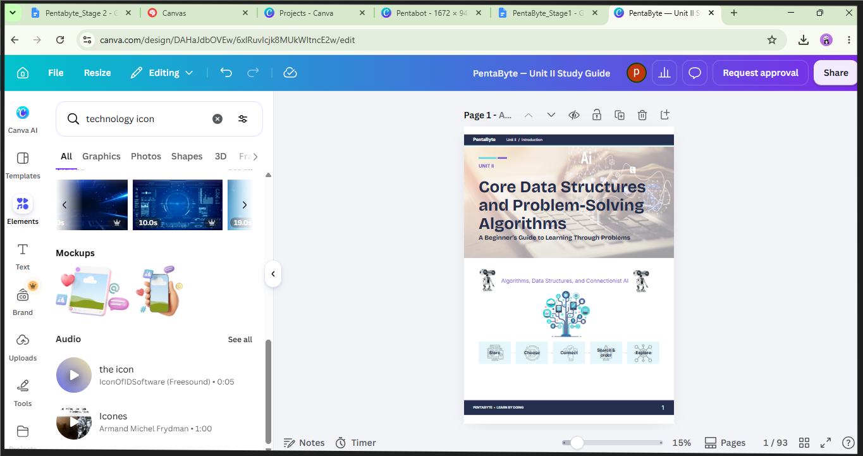
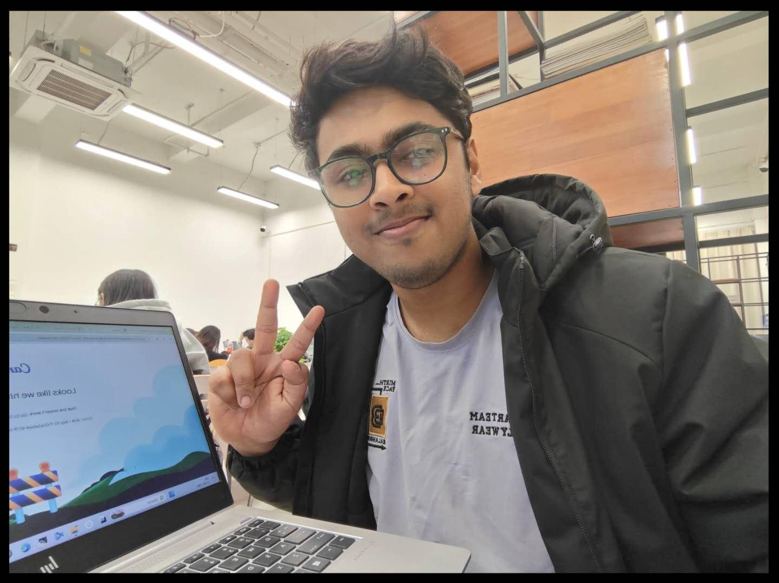
Making study guide for beginners___

Date: November 6, 2026

Video Tutorial Research, Script Development, and Recording
Activity and Purpose
Today, I focused on producing a video tutorial for my assigned Unit II. My main objective was to create a professional, informative, and engaging educational video that could effectively explain the chapter's concepts to beginner-level students. Before recording, I conducted research on different approaches to video production, explored educational video examples, and prepared a step-by-step guide to organize the production process.
My Contribution
I carried out several activities to develop the video tutorial:
- Research and Preparation: Conducted research using Google and Claude to explore effective approaches to creating educational video tutorials and improving their overall quality.
- Video Production Planning: Prepared a personal step-by-step guide outlining the process of producing a professional educational video, including preparation, presentation, narration, and recording.
- Reference Research: Explored YouTube to study existing educational tutorials, observe how technical topics are explained, and understand different techniques for making videos more professional and engaging.
- Script Development: Prepared a video narration script to organize the explanations and ensure that the content could be presented in a clear and structured manner.
- Team Communication: Shared the prepared tutorial with the main team group for inspection and feedback.
- Video Recording: After completing the preparation and script, I recorded the video tutorial in my room.
Outcome
I completed the preparation and recording of the video tutorial for my assigned chapter. The research and planning process helped me establish a more organized approach to video production, while the prepared script provided a clear structure for presenting the learning content. I also shared the tutorial with the main team group for inspection, allowing it to be reviewed as part of the team's overall quality-control process.
Learning and Reflection
Today's work gave me valuable experience in educational video production. I realized that producing a professional tutorial requires more than simply recording a presentation. It involves researching suitable teaching methods, organizing the content, preparing a clear script, and considering how the information will be presented to the audience. Watching different educational videos on YouTube also helped me observe how presenters explain technical concepts in an understandable and engaging way. Furthermore, preparing a personal step-by-step production guide helped me organize my work more effectively. Overall, this experience improved my understanding of how to transform academic content into an accessible video-based learning resource.
Purpose: To research effective educational video production methods, prepare a structured tutorial script and production guide, record a video tutorial for my assigned Unit II chapter, and share the result with the team for inspection.
Verification: The completed video tutorial can be reviewed to verify its content, presentation, and overall quality. The narration script and personal production guide can be compared with the recorded video to check their consistency. The shared video and subsequent feedback can also be verified through the main team group.
Evidence: Research notes and relevant Google and Claude references, YouTube educational video references, the personal step-by-step video production guide, completed video narration script, recorded video tutorial, and screenshot of the video shared in the main team group for inspection.

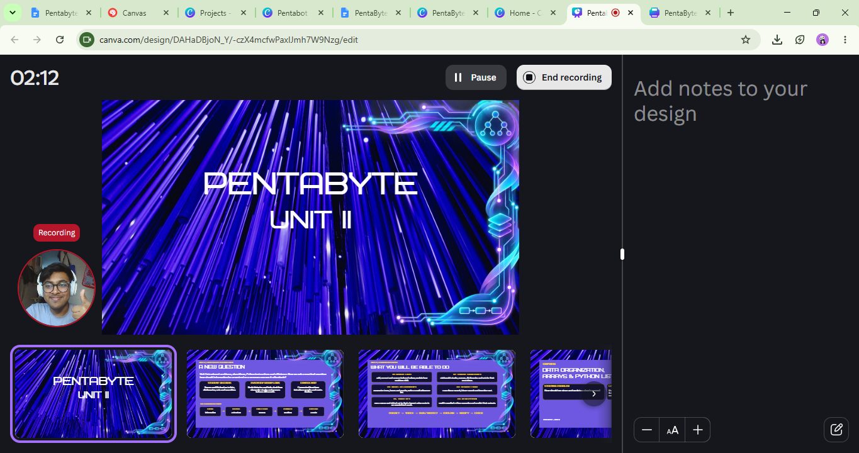
Start to make a video for the chapters___

November 7, 2026

Final Project Review, GitHub Upload, and Submission Coordination
Activity and Purpose
Today, I focused on reviewing and organizing all the work I had completed for my assigned Unit II responsibilities. My main objective was to ensure that the required project materials were properly prepared, check that no important tasks or files had been overlooked, and upload the completed work to the team's GitHub repository before the submission deadline.
My Contribution
I carefully reviewed my completed tasks and checked the status of each assigned deliverable to ensure that the required work had been completed. I examined my project files and organized the materials before proceeding with the upload.
After completing the review, I uploaded all my prepared project files to the team's GitHub repository. I then shared the uploaded materials with the team leader, who was responsible for collecting the members' contributions and submitting the team's Stage 2 work.
Outcome
I completed the final review of my assigned work and successfully uploaded my prepared project files to GitHub. I also informed the team leader and provided access to my uploaded materials for the team's final submission process. This helped ensure that my individual contributions were available for collection and inclusion in the team's submission.
Learning and Reflection
Today's work helped me recognize the importance of conducting a thorough review before submitting an academic project. Even after completing the main tasks, checking file organization, reviewing deliverables, and ensuring that all required materials are available are essential parts of the submission process. I also gained a better understanding of the importance of GitHub in collaborative projects, particularly for organizing contributions and making project files accessible to other team members. Overall, this experience reminded me that completing a task is not the final step; proper documentation, file management, and communication are equally important.
Purpose: To review the completion of my assigned Unit II tasks, organize and upload the prepared project materials to GitHub, and coordinate with the team leader for the final Stage 2 submission.
Verification: The uploaded project files can be verified through the team's GitHub repository and their corresponding upload or commit records. Communication with the team leader can also be checked to confirm that the materials were shared for the final submission process.
Evidence: GitHub repository link, relevant upload or commit screenshots, the completed Unit II project files, and communication records showing that the materials were shared with the team leader.

All files are ready, uploading files one by one___
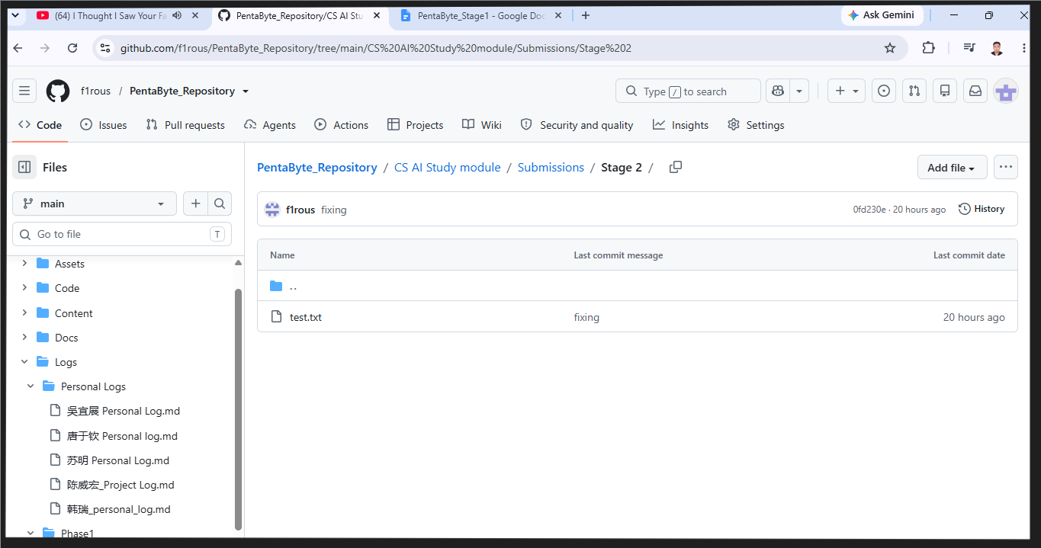

END of stage- 02

